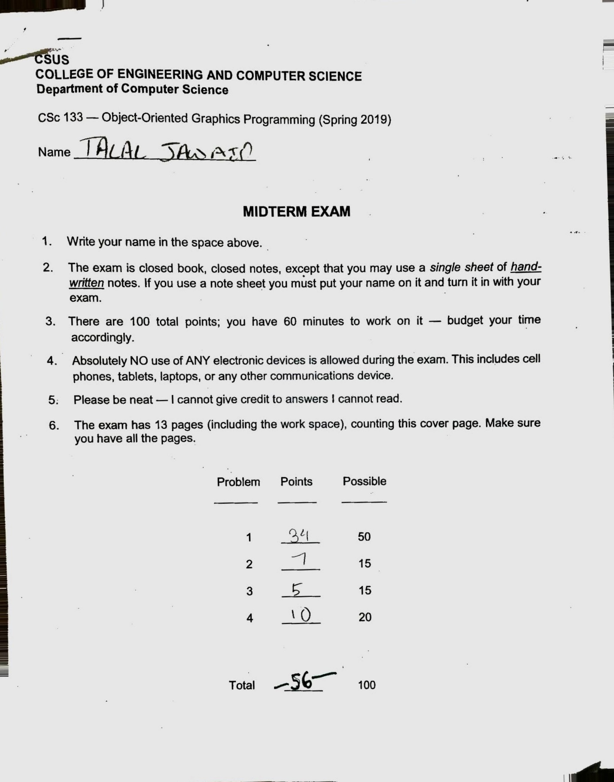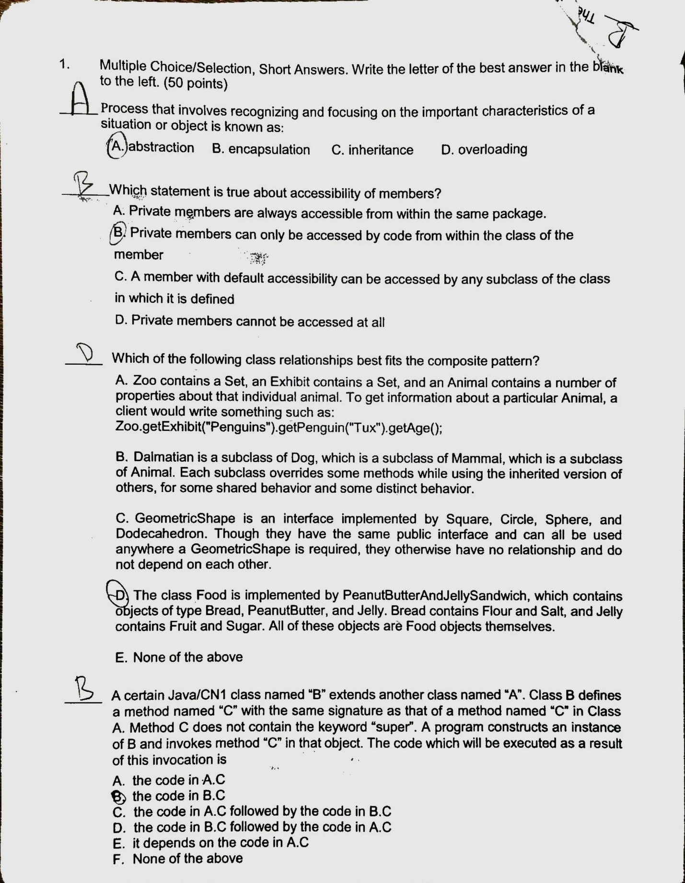

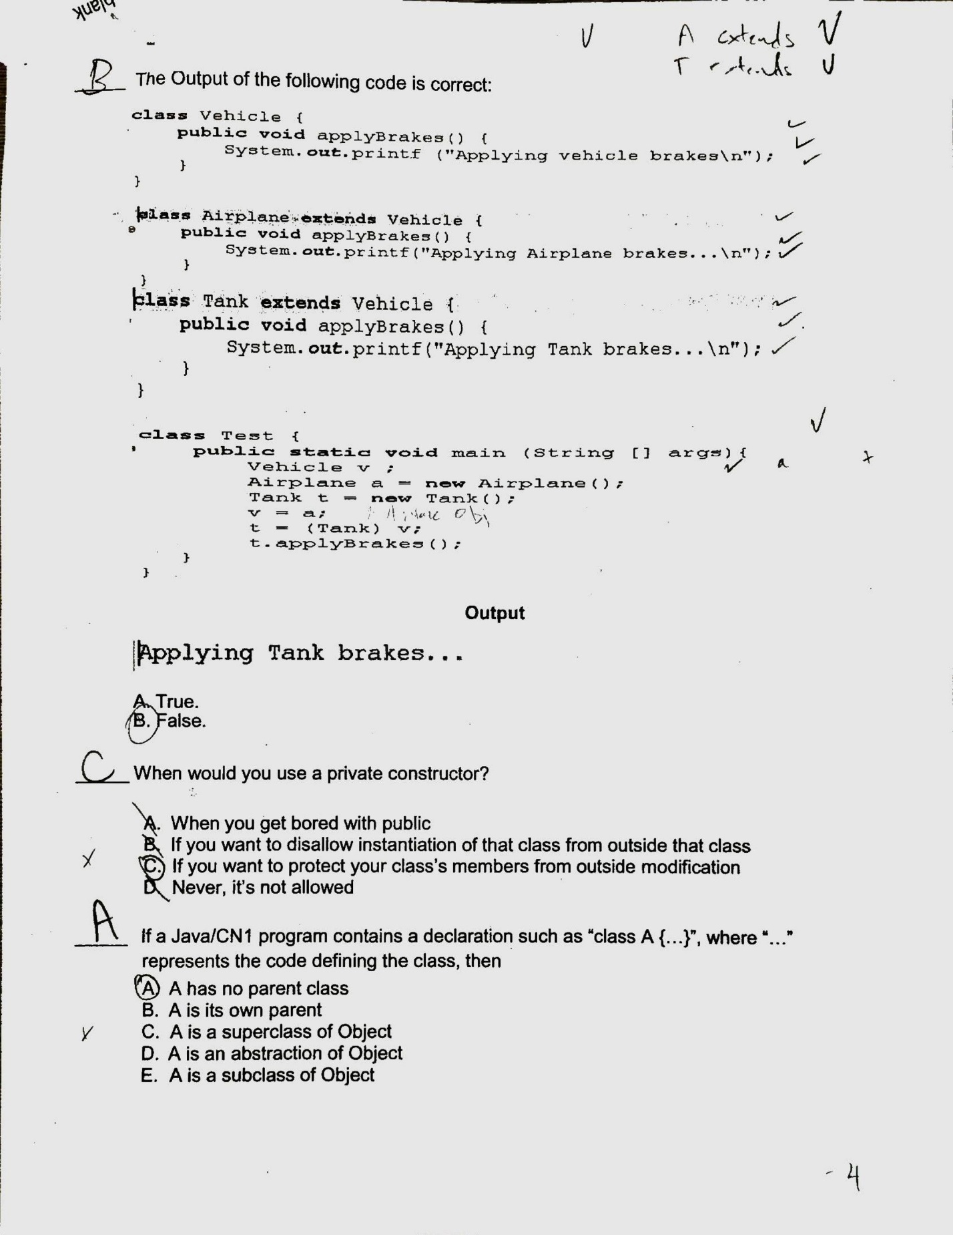

**_____When would you use a private constructor?**

**Correct answer: B**

You use a private constructor when you want to ensure that the only way to instantiate that class is within the class itself. This ensures that no outside class can instantiate that class.

**If a JAVA/CN1 program contains a declaration such as “class A {…}”, where “…” represents the code defining that class, then:**

**Correct Answer: E,** A is a subclass of object

The base class is called Object. Every other class is either a direct or indirect subclass of Object. In this situation where Class A has no parent, then it is a direct subclass of Object.

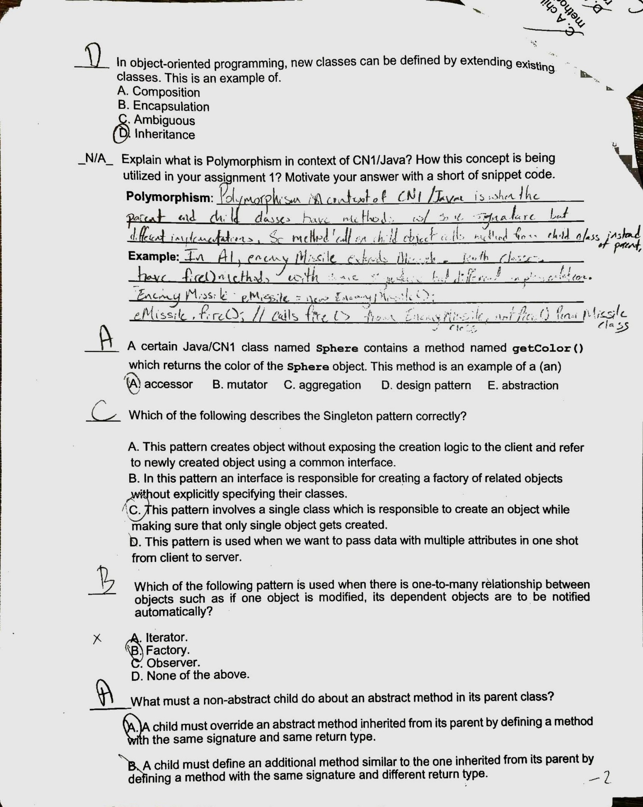

**Which fo the following pattern is used when there is one-to-many relationship between objects such as if one object is modified, its dependent objects are to be notified automatically?**

**Correct Answer: C, Observer**

In the observer pattern, the dependent objects are notified and updated automatically when one object is modified. This observer pattern is necessary for use with one-to-many relationships

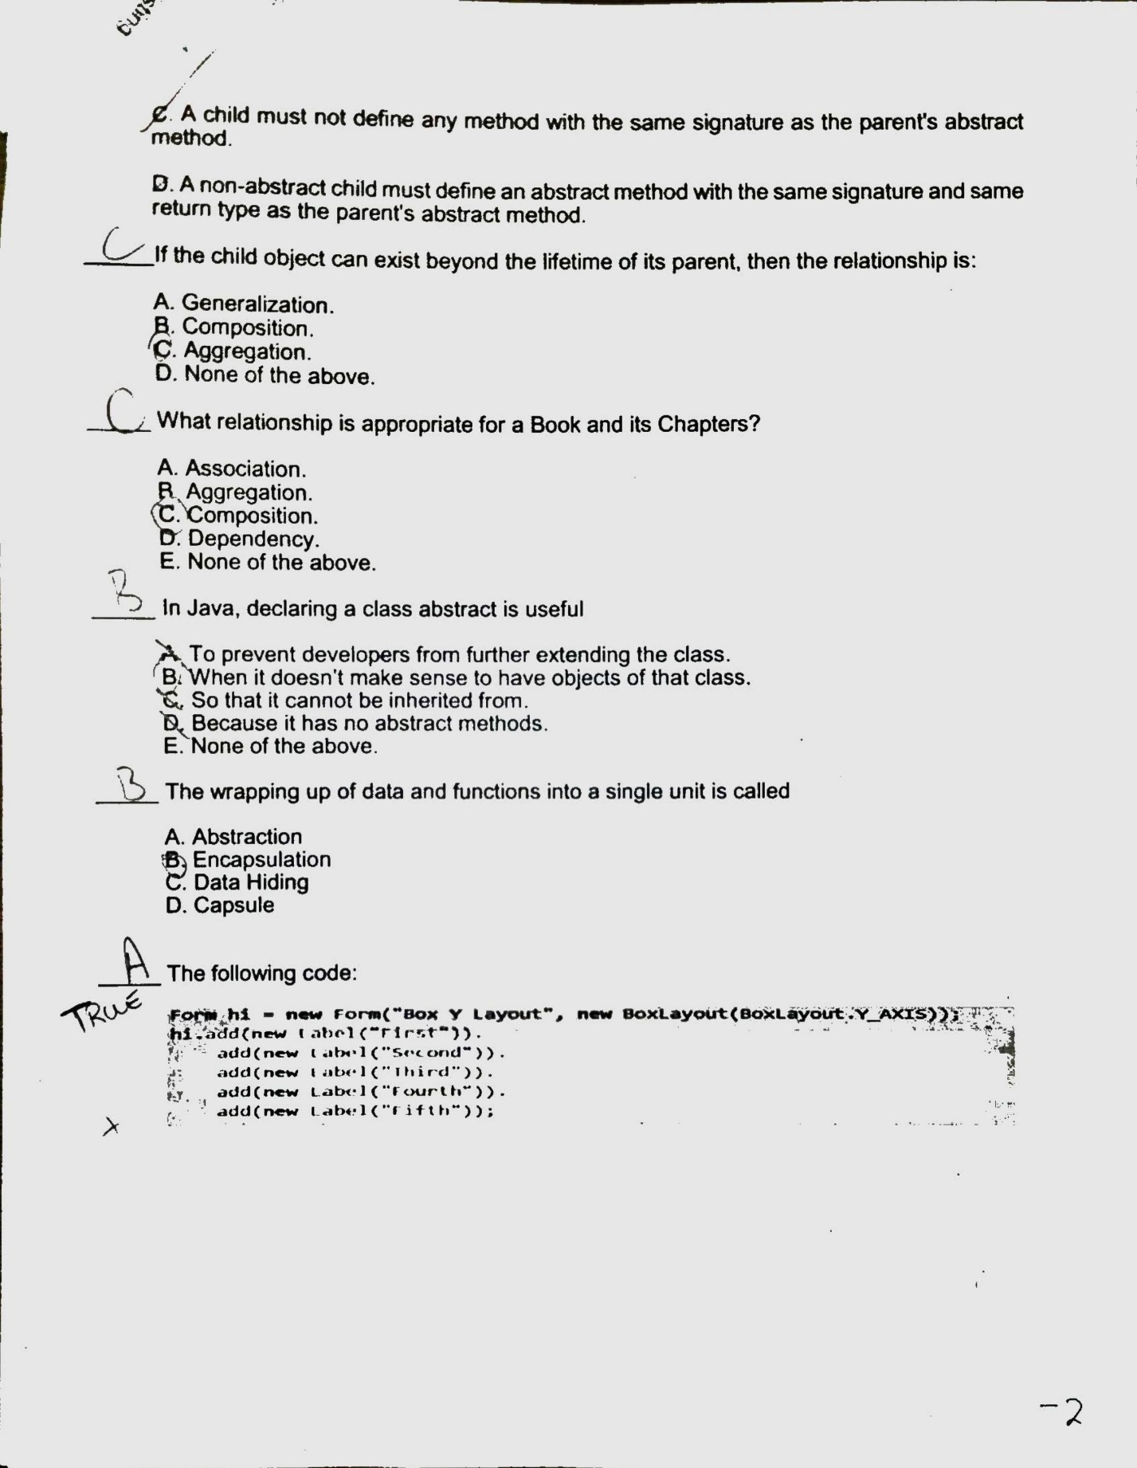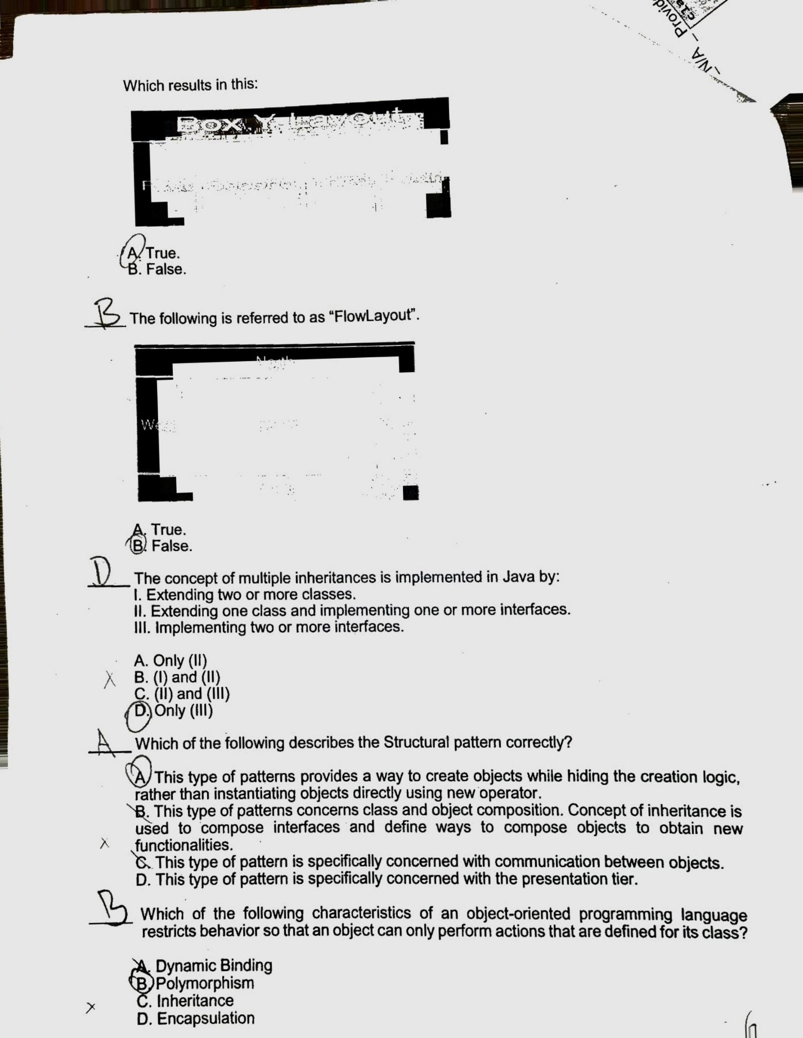

**The following code results in this: which is referred to as Box Y Layout image**

**Correct Answer: B. False**

This is incorrect, the fifth box is missing.

**The concept of multiple inheritances is implemented in Java by:**

**Correct Answer: C,**

Extending one class and implementing one or more interfaces is the only way to implement the concept of multiple inheritances in Java

**Which of the following describes the Structural pattern correctly?**

**Correct Answer: B**

**The Structural pattern concerns the class and object composition. Only in the structural pattern is the concept of inheritance used to compose interfaces and define ways to compose objects to obtain new functionalities.**

**Which of the following characteristics of an oo programming language restricts behavior so that an object can only perform actions that are defined for its class?**

**Correct Answer: D**

Encapsulation is a way of ensuring that methods are only allowed to modify objects within their scope.

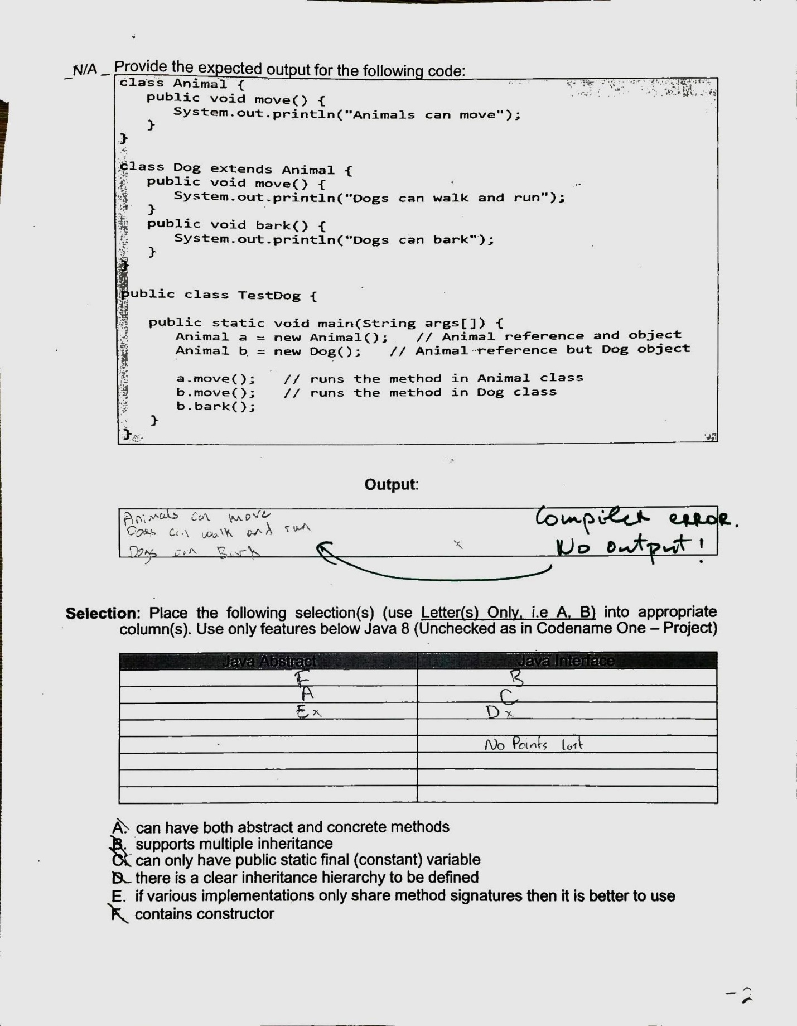

**The line Animal b = new Dog() is invalid.**

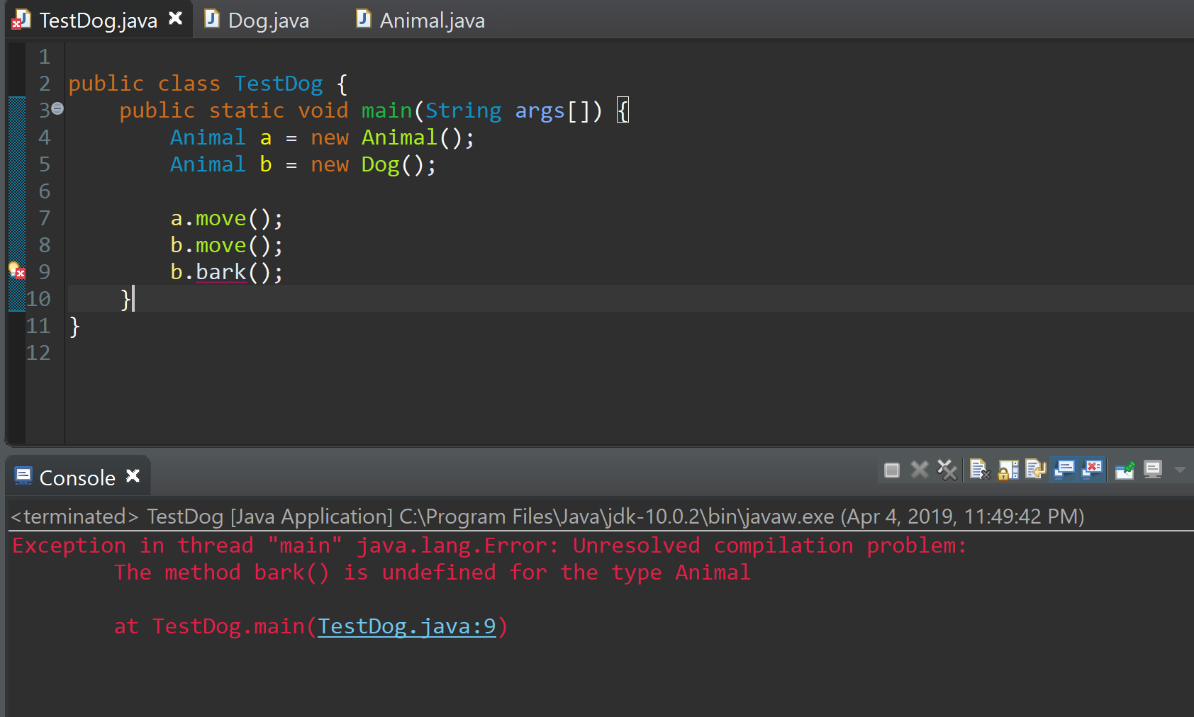

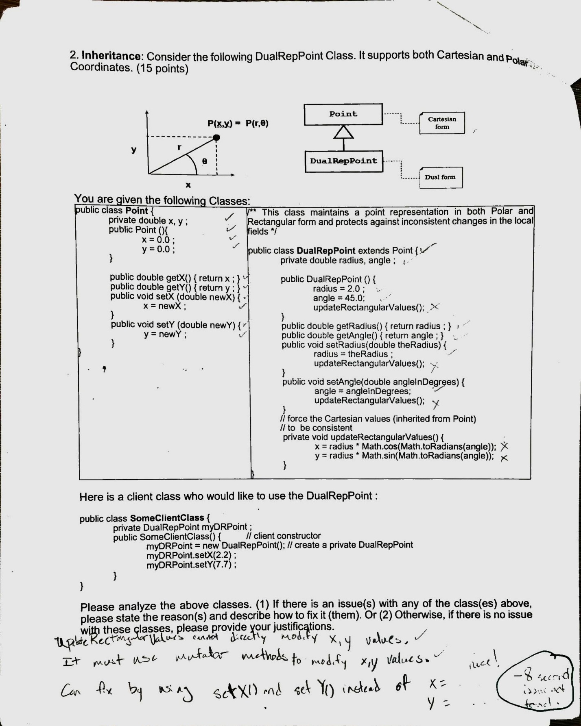

**Correct Answer: The second issue with the classes is that when rectangular values are updated, it is not ensured that the polar form coordinates are also updated simultaneously. This leads to a discrepancy in the values.**

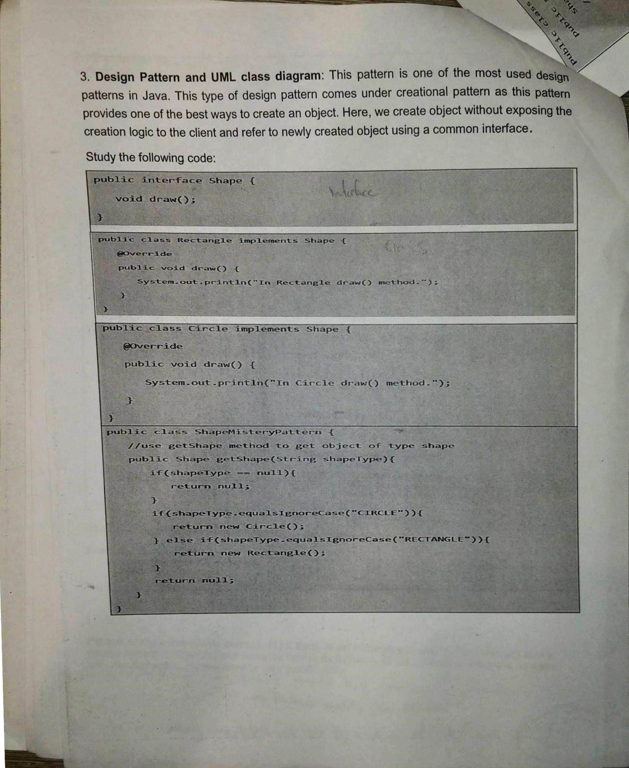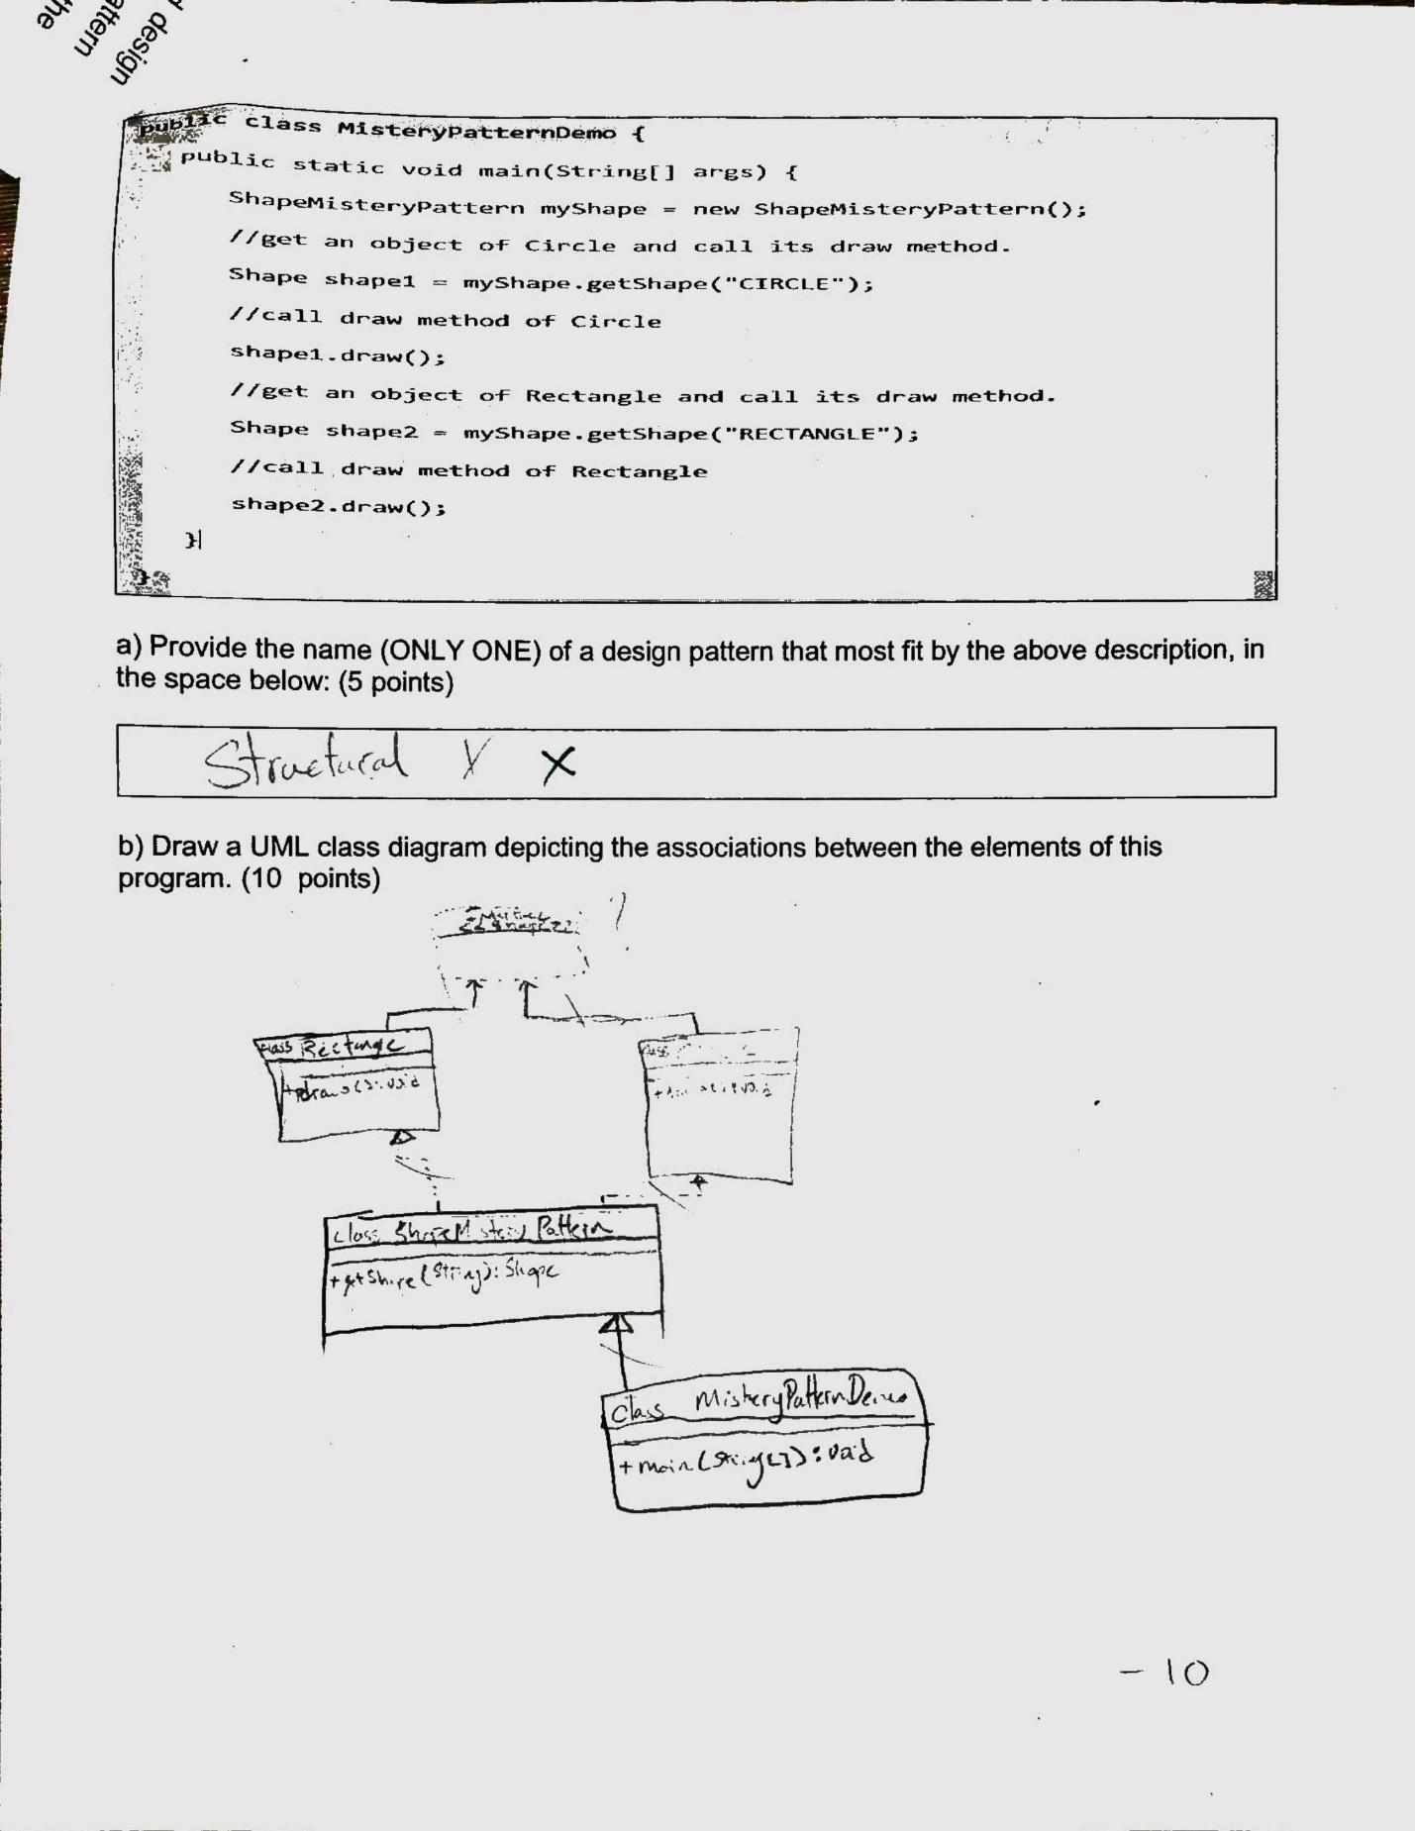

**Correct Answer:** Factory pattern comes under creational pattern as this pattern is one of the best ways to create an object. This is the pattern used in the given code.

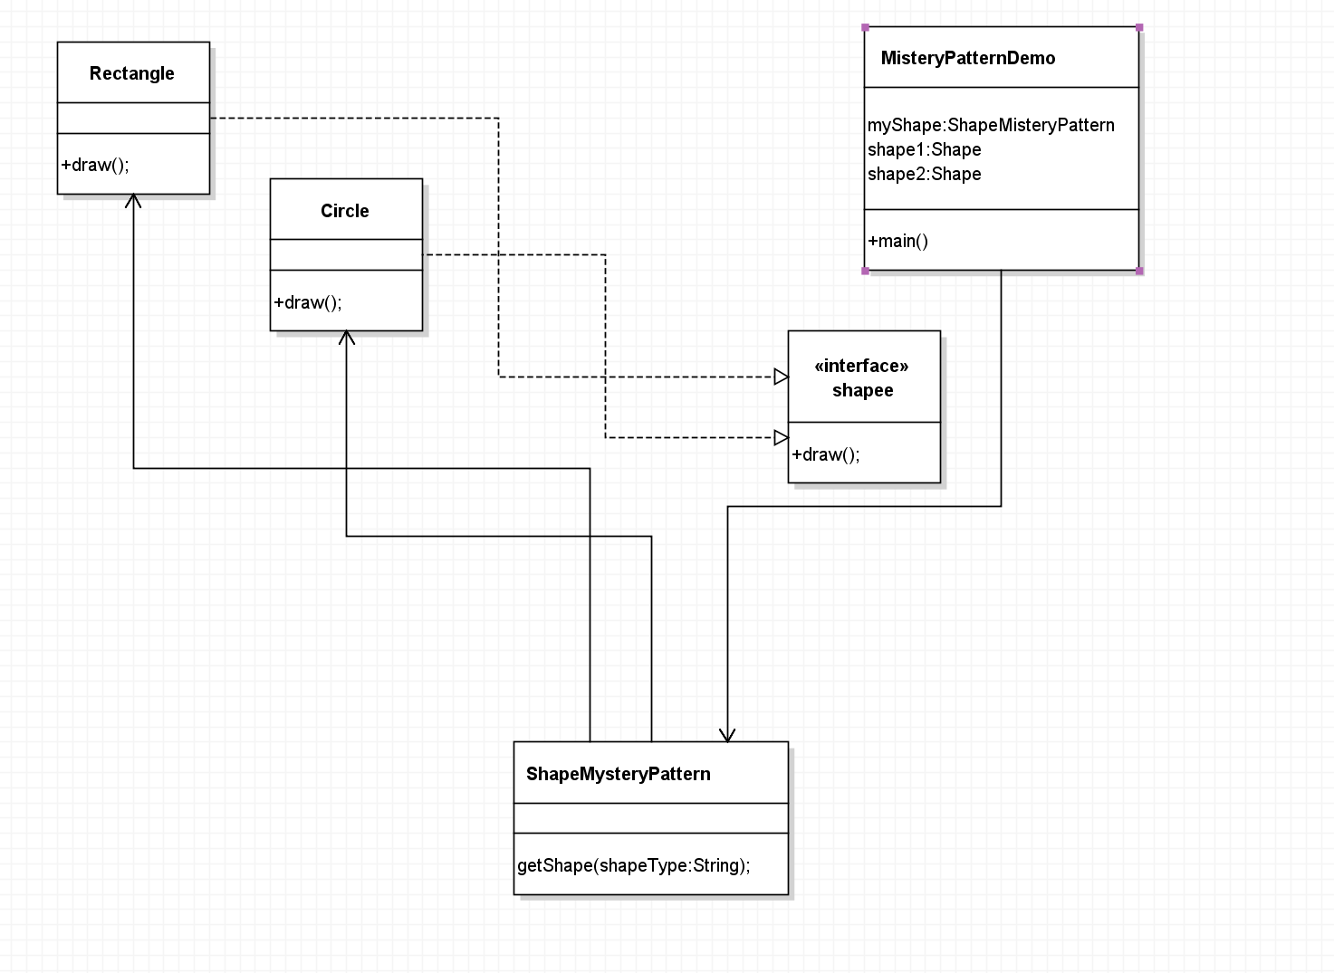

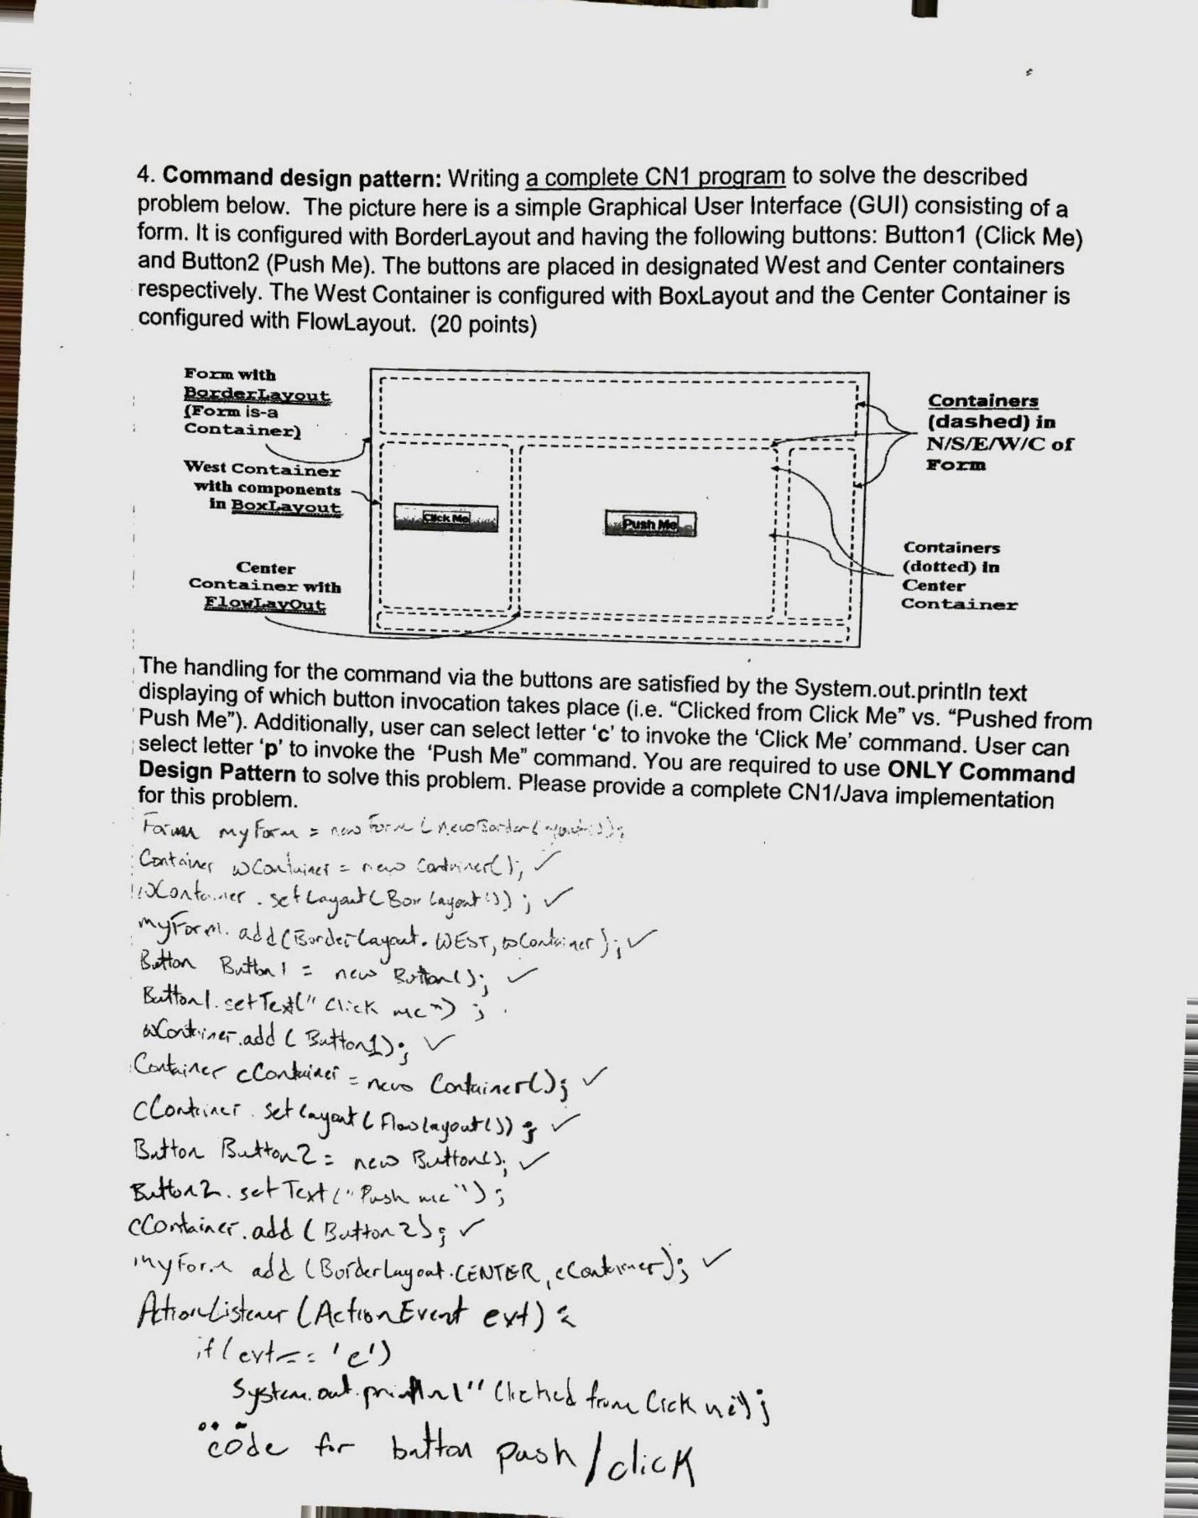

**Correct Answer:**